**Practical No. 01**

**Aim:** Setting up the git client.

**Git Installation:** Download the Git installation program (Windows, Mac, or Linux) from Git - Downloads ([https://www.git-scm.com/](https://git-scm.com/)).

When running the installer, various screens appear (Windows screens shown). Generally, you can accept the default selections, except in the screens below where you do not want the default selections:

In the Select Components screen, make sure Windows Explorer Integration is selected as shown:

**Setting up of Git Client**

For Windows, you can use Git bash, which comes included in Git for Windows. For Mac and Linux you can use the built-in terminal.

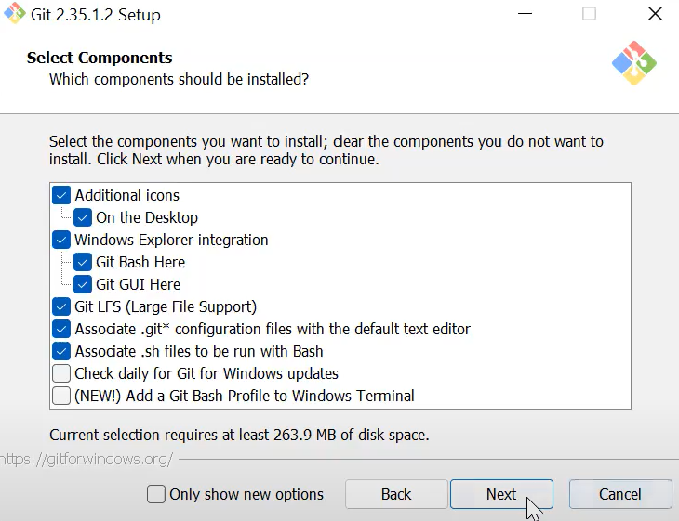

We’ll be choosing vim text editor, though you can choose any of your choice. This can also be changed later on.

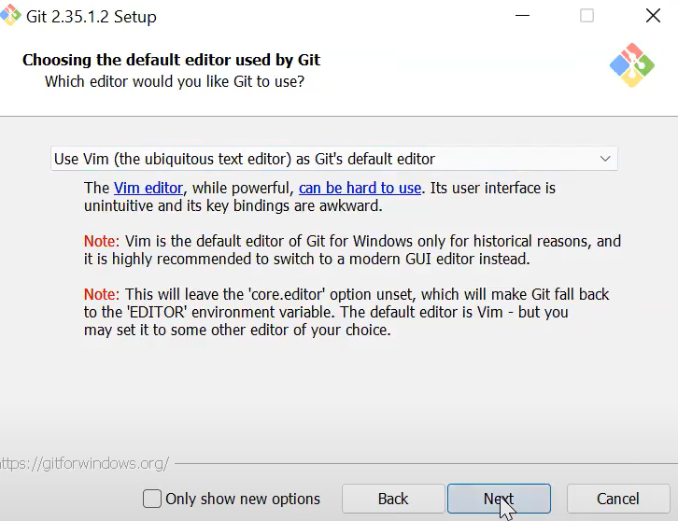

Next we’ll choose the name of the initial git repositories, we’ll go forward with the default setting i.e. master.

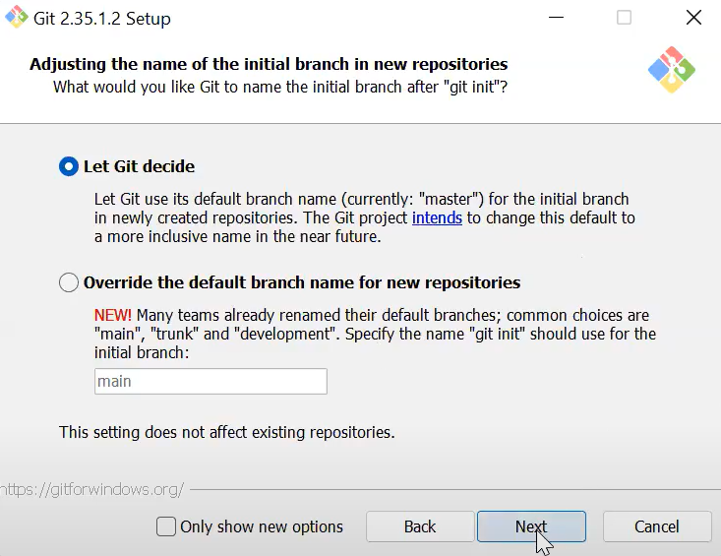

In the Adjusting your PATH screen, all three options are acceptable:

1. Use Git from Git Bash only: no integration, and no extra command in your command path.

2. Use Git from the windows Command Prompt: add flexibility – you can simply run git from a windows command prompt, and is often the setting for people in industry – but this does add some extra commands.

3. Use Git and optional Unix tools from the Windows Command Prompt: this is also a robust choice and useful if you like to use Unix like commands like grep.

Though, for this course we’ll be using Git Bash only

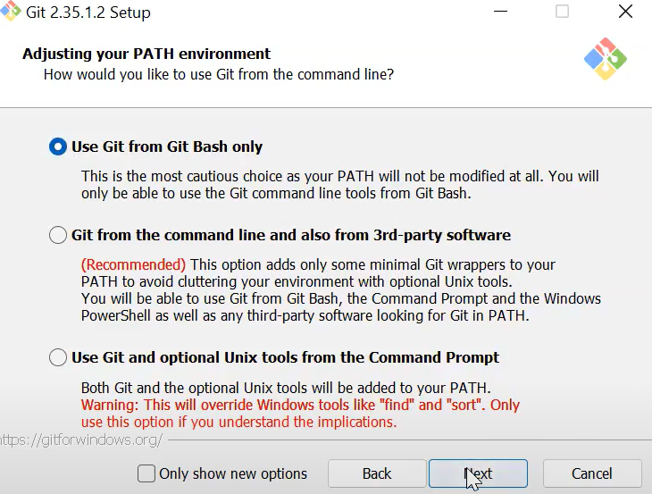

Git uses SSH keys to securely access your repositories, and in Windows SSH keys are often searched on the wrong path when you try to use Git. It is recommended to use open SSH.

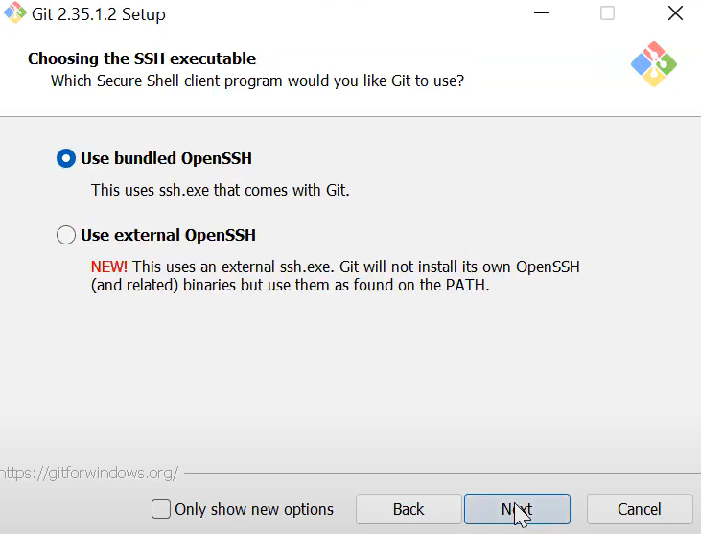

In the Configuring the line ending screen, select the first option (Checkout Windows-style, commit Unix-style line endings) as it is the most convenient.

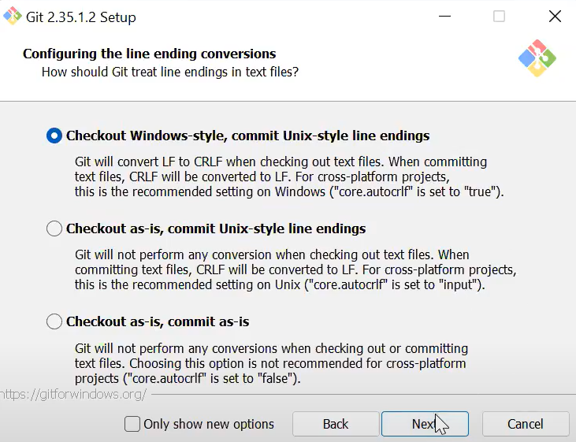

Next choose the default MinTTY terminal and default ‘git pull’ behaviour. Use the Git credential manager and enable file system cashing for better performance. Enable experimental support for pseudo consoles and click ‘install’.

Once Git is installed, the first thing we need to do, is to check if Git is properly installed. If Git is installed, it should show something like git version X.Y

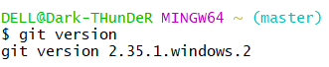

Now let Git know who you are. This is important for version control systems, as each Git commit uses this information:

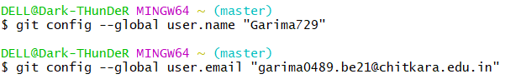

Change the user name and e-mail address to your own. You will probably also want to use this when registering to GitHub later on.